**Exercise on Innovating and Solving Real-World Problems with Laravel**

**Course:** Web Development with Laravel Framework

**Level:** Bachelors CCN2021

**Name:** Braxton Oneal Radol SCCJ/01453/2019

**Total Marks:** 100

**Objective:**

This exercise aims to provide students with hands-on experience in developing web applications

using the Laravel framework. Students will learn how to apply their knowledge to solve real-

world problems by creating innovative web solutions.

**Part 1: Introduction to Laravel (10 Marks)**

**1. Installation and Setup (5 Marks**):

o Install Laravel using Composer.

o Set up a new Laravel project.

o Configure the environment settings in the .env file.

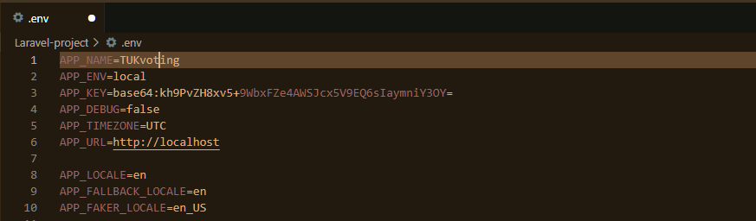

o Start the development server and ensure it is running correctly.

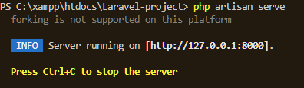

After using the link http://127.0.0.1:8000:

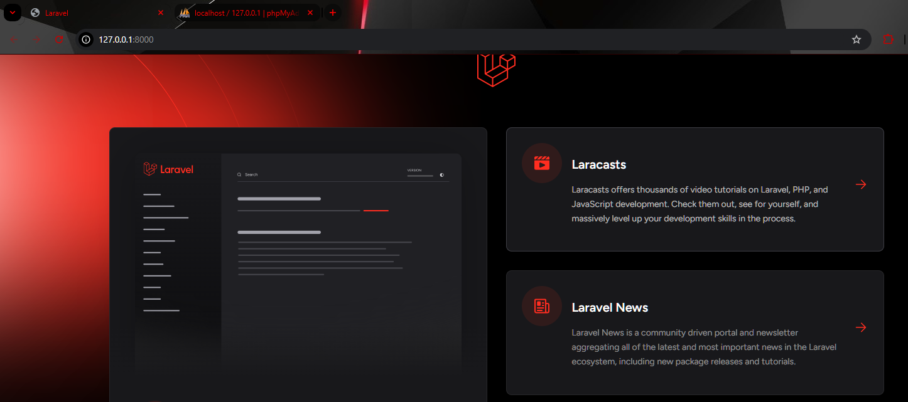

**2. Basic Routing and Controllers (5 Marks):**

o Create a basic route that returns a view.

Basic route:



View:

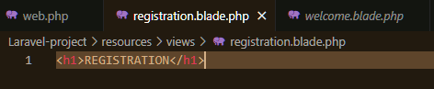

Web page:



o Create a simple controller with a method that returns a view.



After creating:

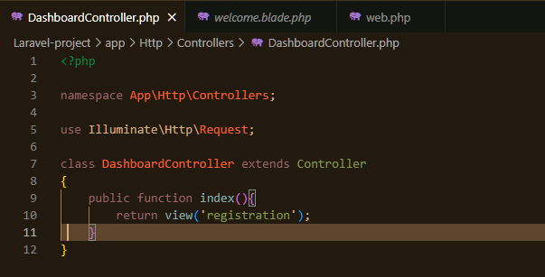

Setting route:

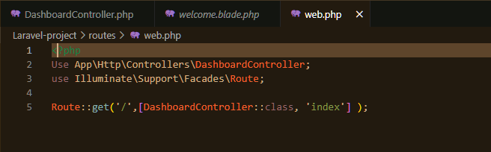

o Pass data from the controller to the view.



**Part 2: Building the Application (40 Marks)**

**3. Database Configuration and Migration (10 Marks):**

o Set up a MySQL database for the project.



o Configure the database connection in the .env file.

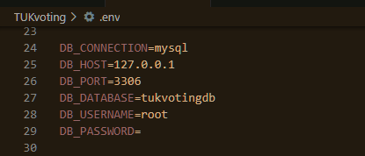

o Create and run migrations to set up the necessary database tables.

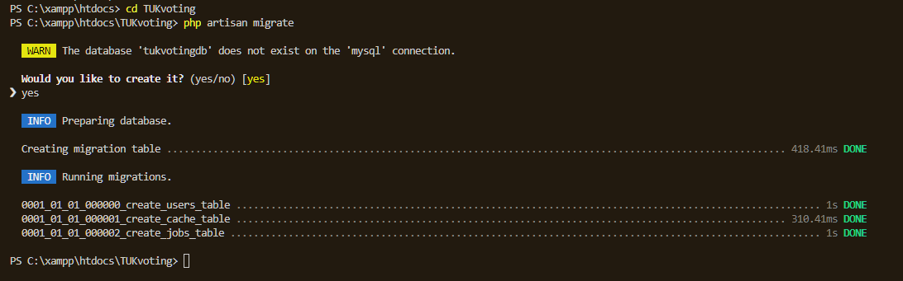

**4. Model and Eloquent ORM (10 Marks):**

o Create a model for the main entity of your application.

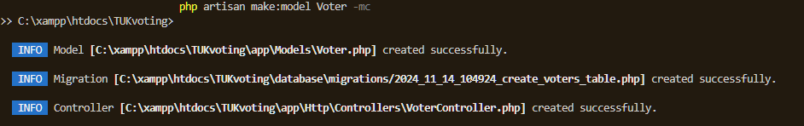

o Use Eloquent ORM to interact with the database.

o Implement CRUD operations (Create, Read, Update, Delete) for the model.

**5. Views and Blade Templating (10 Marks):**

o Create Blade templates for the main views of your application.

o Use Blade directives to display data and control the flow of the application.

o Implement a layout template to be extended by other views.

**6. Form Handling and Validation (10 Marks):**

o Create forms for data input.

o Implement server-side validation for form inputs.

o Display validation errors in the views.

Part 3: Advanced Features (30 Marks)

7. Authentication and Authorization (10 Marks):

o Implement user authentication using Laravel’s built-in features.

o Restrict access to certain parts of the application based on user roles.

o Implement user registration and login functionality.

8. AJAX and API Integration (10 Marks):

o Use AJAX to create a dynamic and responsive user interface.

o Integrate a third-party API into your application.

o Display data retrieved from the API in your views.

Part 4: Project Submission and Presentation (20 Marks)

10. Project Report (15 Marks):

o Write a detailed report documenting the development process.

o Include screenshots, code snippets, and explanations of key features.

o Discuss any challenges faced and how they were overcome.

11. Project Presentation (15 Marks):

o Prepare a presentation to demonstrate your application.

o Explain the problem your application solves and how it innovates.

o Showcase the key features and functionality of your application.

o Answer questions from the audience and receive feedback.

Real-World Problem Examples:

1. Local Business Directory:

o Create a web application that allows users to search for local businesses, view

details, and leave reviews.

o Implement a real-time notification system to inform business owners of new

reviews.

2. Event Management System:

o Develop an application for organizing and managing events, including ticket

sales, attendee registration, and event updates.

o Use AJAX for a smooth user experience and integrate with a payment gateway

API.

3. Online Learning Platform:

o Build a platform for online courses, allowing instructors to upload content and

students to enroll and participate in courses.

o Implement authentication and role-based access control for instructors and

students.

Submission Guidelines:

• Submit the project report as a PDF document.

• Deploy the application to a web server (e.g., Heroku, AWS) and provide the URL.

• Include a link to the GitHub repository containing the project source code.